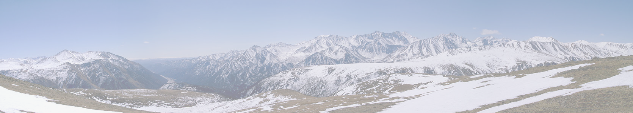
INTERNATIONAL WORKSHOP
«CONTIGENCY MANAGEMENT, INTELLIGENT, AGENT-BASED COMPUTING AND CYBER SECURITY IN Critical InfrastructureS»
(CM/IAC/CS/ CI - 2016)

Organizer: Melentiev Energy System Institute SB RAS, Irkutsk
Dates: March, 11-16, 2016. Working language: English. Venue: Irkutsk, Listvjanka, Baikal Hotel (Eastland). From Irkutsk to Listvjanka - 65 km.

Scientific topics:
- Contingency management in critical infrastructures based on integration of mathematics and intelligent technologies: theory, methods, development trends.
- Theoretical and methodological issues of development and integration of intelligent, agent-based and cloud computing for contingency management in critical infrastructures
- Situational awareness, semiotics, visual analytics, semantic modeling and their applications in critical infrastructures.
- Application of intelligent, agent-based and cloud computing to support decision making in research and ensuring of energy security.
- Methods, technologies and equipment for collecting and processing of data streams in Smart power systems, the possibility to apply the concept of Big Data.
- Support of collective expert activities in the scientific research and decision making.
- Cyber security of critical infrastructures.

Workshop schedule:
March 11, 2016 – transfer Irkutsk - Listvjanka.
March 12-15, 2016 – scientific sessions and discussions.
March 16, 2016 – transfer Listvjanka - Irkutsk.

Deadlines:
February 1, 2016 - accepting report title and desirable price accommodation.
February 8, 2016 – accepting of abstracts for publication (in English and in Russian) February 20, 2016 – sending of personal invitations and additional information.

Conditions of participation:
Participation is possible only with a report. It's possible participation of accompanying persons. Organizing fee for both – 1000 rubles, for graduate and postgraduate students: 500 rubles.

Accommodation: in double comfortable rooms in the Baikal Hotel (Listvjanka).
The prices of accommodation (only breakfast inclusive) per one person:
From 850-1100 rub. (economy or standard) to 1250 (two-room family) rubles per day. Web-site http://eastland.pro (select "Directions of activity": "Hotel Baikal").

Сontacts: e-mail: massel@isem.sei.irk.ru, tel: 89148736049, Liudmila Massel.

